SIMATS ENGINEERING
ASSESSMENT TOOL 1

COURSE NAME: MLA0303
COURSE CODE: Reinforcement learning for Environment and Agent

COURSE OUTCOME COVERED

CO1: Analyze reinforcement learning frameworks and Markov Decision Process concepts to model decision-making problems. (BL2, BL3)

Assessment Tool Weightage: 50%

Dr. Dumpala Prasanth

QUESTIONS: 10 Total Marks: 50

Annexure A

RL Basic Experiments demo with Keras and TensorFlow using Anaconda navigator

Duration: 2hrs

Experiment 1: Installation of Reinforcement Learning Development Environment

Aim: To install and configure Anaconda Navigator, Python, TensorFlow, Keras, Gymnasium (OpenAI Gym), NumPy, Matplotlib, and other required libraries, and verify the environment by executing a simple Reinforcement Learning program.

Experiment 2: Familiarization with OpenAI Gym/Gymnasium Environments

Aim: To create, initialize, and interact with standard Reinforcement Learning environments such as FrozenLake, CartPole, and MountainCar using Gymnasium to understand the concepts of states, actions, rewards, and episodes.

Experiment 3: Implementation of the Reinforcement Learning Framework

Aim: To implement the basic Reinforcement Learning framework by designing an agent that interacts with an environment through states, actions, rewards, and policies using Python.

Experiment 4: Simulation of a Markov Decision Process (MDP)

Aim: To develop a simple Markov Decision Process model and simulate state transitions, reward functions, and policy execution for understanding sequential decision-making problems.

Experiment 5: Bellman Equation Demonstration

Aim: To implement Bellman Expectation and Bellman Optimality Equations for calculating state-value and action-value functions and analyze the convergence of value estimation.

Experiment 6: Exploration vs. Exploitation Strategies

Aim: To implement ε-Greedy, Greedy, and Random action-selection strategies and compare their performance in balancing exploration and exploitation during Reinforcement Learning.

Experiment 7: Multi-Armed Bandit Problem

Aim: To implement the Multi-Armed Bandit problem using ε-Greedy and Upper Confidence Bound (UCB) algorithms and evaluate cumulative rewards obtained by different action-selection methods.

Experiment 8: Reward Visualization in Reinforcement Learning

Aim: To simulate an RL agent in a simple environment and visualize cumulative rewards, episode rewards, and learning performance using Matplotlib graphs.

Experiment 9: TensorFlow and Keras-Based Neural Network for RL

Aim: To build a simple feed-forward neural network using TensorFlow and Keras for approximating value functions in Reinforcement Learning environments.

Experiment 10: Mini Reinforcement Learning Project Using CartPole

Aim: To develop a basic Reinforcement Learning agent using TensorFlow and Keras to solve the CartPole environment and evaluate its learning performance through episode rewards and success rate.

Code of Conduct:

I __________B.Vani__________ (Name / Reg No) certify that this submission is my original work and that I have adhered to the guidelines specified for this assessment.
I understand that any violation of academic integrity rules will result in disciplinary action.

Signature of the student:
B.Vani

Experiment 1: Installation of Reinforcement Learning Development Environment
Aim:
To install and configure Anaconda Navigator, Python, TensorFlow, Keras, Gymnasium, NumPy, and Matplotlib, and verify the setup using a simple Reinforcement Learning program.
Theory
- Anaconda manages Python environments.
- TensorFlow and Keras build neural networks.
- Gymnasium provides RL environments.
- NumPy performs numerical operations.
- Matplotlib visualizes results.
Explanation
- Imports required libraries.
- Creates the CartPole environment.
- Executes random actions.
- Displays the total reward.
Applications
- Robotics
- Game AI
- Autonomous systems
Conclusion
The RL environment was successfully installed and verified.

Experiment 2: Familiarization with OpenAI Gym/Gymnasium Environments
Aim:
To create, initialize, and interact with Gymnasium environments such as FrozenLake, CartPole, and MountainCar to understand states, actions, rewards, and episodes.
Theory
- Gymnasium provides standard Reinforcement Learning environments.
- A state represents the current condition of the agent.
- An action is the decision taken by the agent.
- A reward indicates the result of an action.
- An episode is one complete interaction with the environment.
Explanation
- Creates a Gymnasium environment.
- Initializes the agent in the environment.
- Performs actions and observes state changes.
- Receives rewards based on the actions.
- Ends the episode when the goal is reached or the task is completed.
Applications
- Robot navigation
- Game AI
- Autonomous vehicles
- Reinforcement Learning research
Conclusion
The Gymnasium environments help understand the basic concepts of Reinforcement Learning, including states, actions, rewards, and episodes.

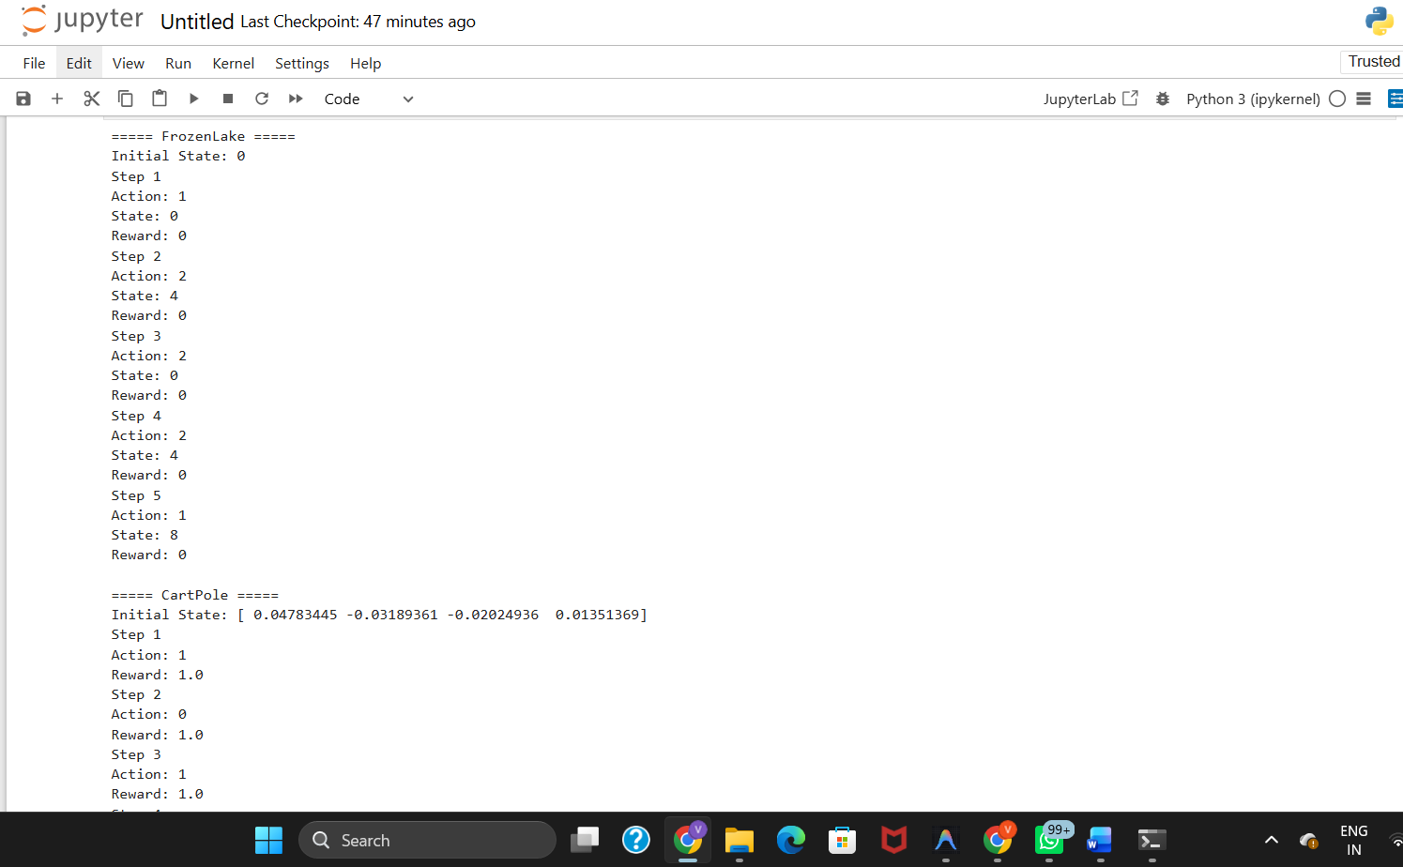
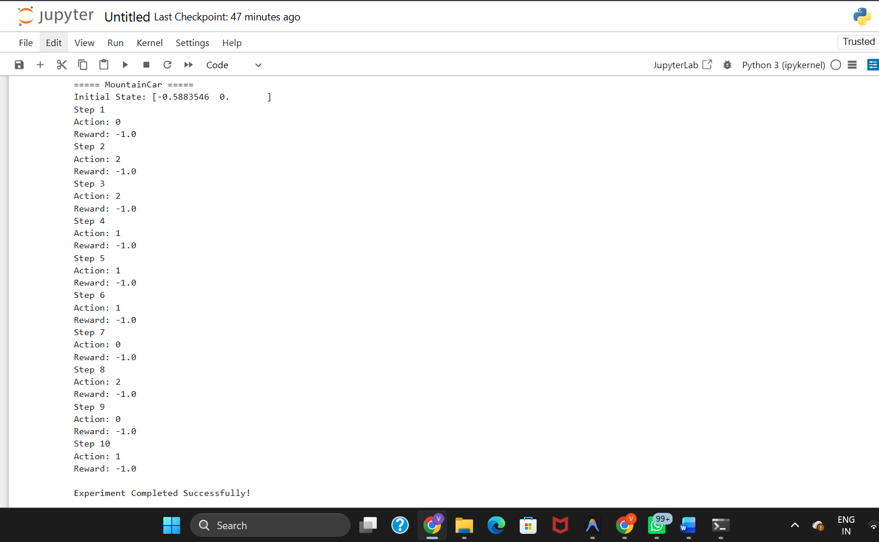
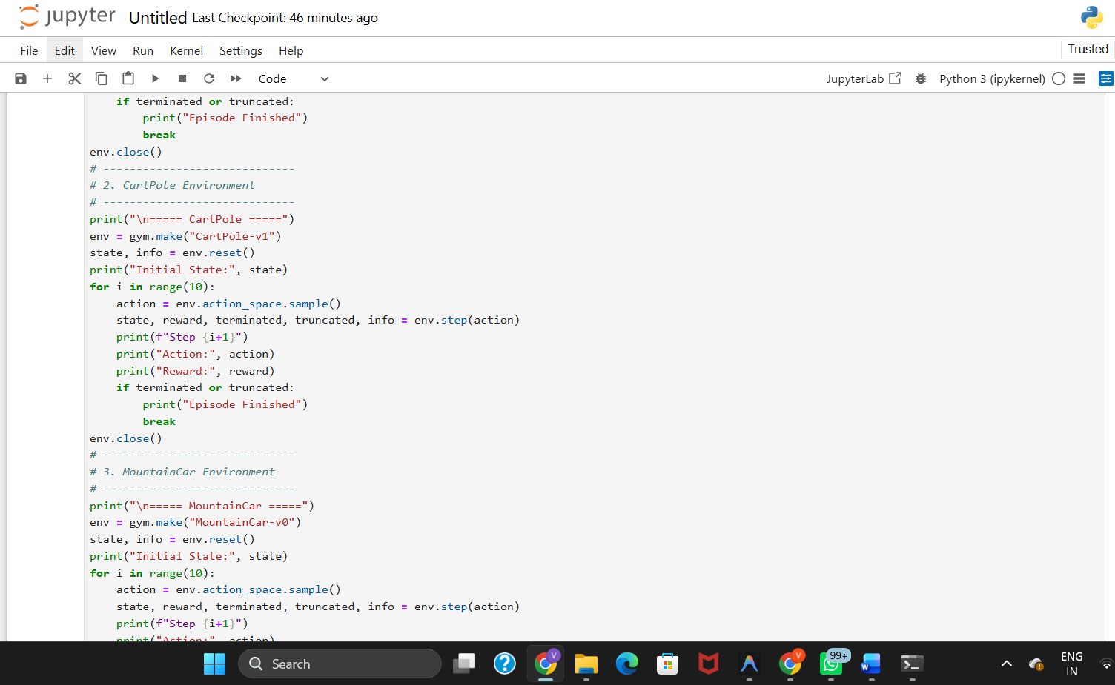
Experiment 3: Implementation of the Reinforcement Learning Framework
Aim:
To implement the basic Reinforcement Learning framework by designing an agent that interacts with an environment through states, actions, rewards, and policies using Python.
Theory
- Reinforcement Learning enables an agent to learn through interaction with an environment.
- The agent observes the current state and selects an action.
- The environment returns the next state and a reward.
- A policy determines how the agent selects actions.
- The goal is to maximize the total reward over time.
Explanation
- Creates an RL agent and environment.
- The agent observes the current state.
- Selects an action based on the policy.
- Receives a reward and moves to the next state.
- Repeats the process until the episode ends.
Applications
- Robotics
- Autonomous vehicles
- Game AI
- Resource management
Conclusion
The Reinforcement Learning framework demonstrates how an agent learns optimal actions by interacting with an environment and maximizing rewards.

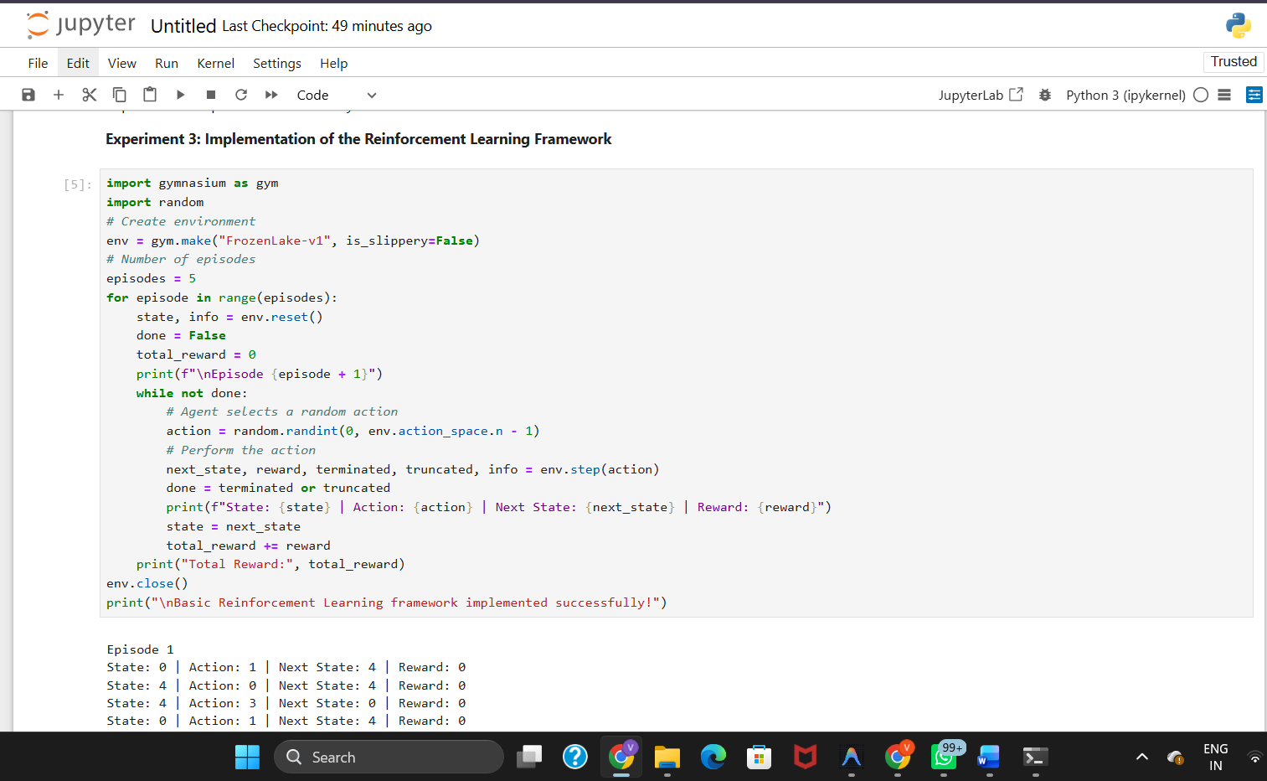
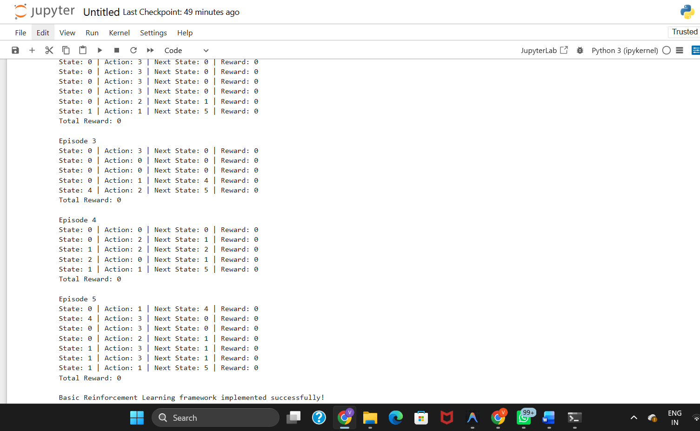

Experiment 4: Simulation of a Markov Decision Process (MDP)
Aim:
To develop a simple Markov Decision Process model and simulate state transitions, reward functions, and policy execution for understanding sequential decision-making problems.
Theory
- A Markov Decision Process (MDP) is a framework for decision-making.
- It consists of states, actions, rewards, and transitions.
- The next state depends only on the current state and action.
- The objective is to maximize cumulative rewards.
- MDP is the foundation of Reinforcement Learning.
Explanation
- Defines states and possible actions.
- Simulates transitions between states.
- Assigns rewards for each action.
- Executes a policy to select actions.
- Displays state changes and rewards.
Applications
- Robot navigation
- Autonomous vehicles
- Game AI
- Route optimization
Conclusion
The MDP model demonstrates how an agent makes sequential decisions by moving between states and maximizing rewards.
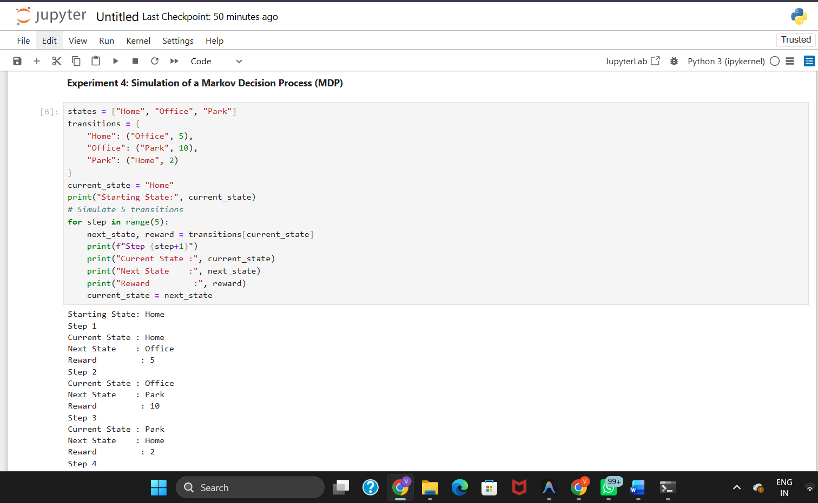

Experiment 5: Bellman Equation Demonstration
Aim:
To implement Bellman Expectation and Bellman Optimality Equations for calculating state-value and action-value functions and analyze the convergence of value estimation.
Theory
- The Bellman Expectation Equation calculates the expected value of a state under a policy.
- The Bellman Optimality Equation finds the maximum value by selecting the best action.
- State-value (V) represents the expected reward from a state.
- Action-value (Q) represents the expected reward for taking a specific action.
- Bellman equations are the basis of many Reinforcement Learning algorithms.
Explanation
- Initializes state values.
- Updates values using the Bellman equations.
- Repeats the process iteratively.
- Estimates the optimal state and action values.
- Observes convergence of value estimates.
Applications
- Robot navigation
- Game AI
- Autonomous vehicles
- Decision-making systems
Conclusion
The Bellman equations estimate optimal state and action values, helping an agent learn the best policy for maximizing long-term rewards.

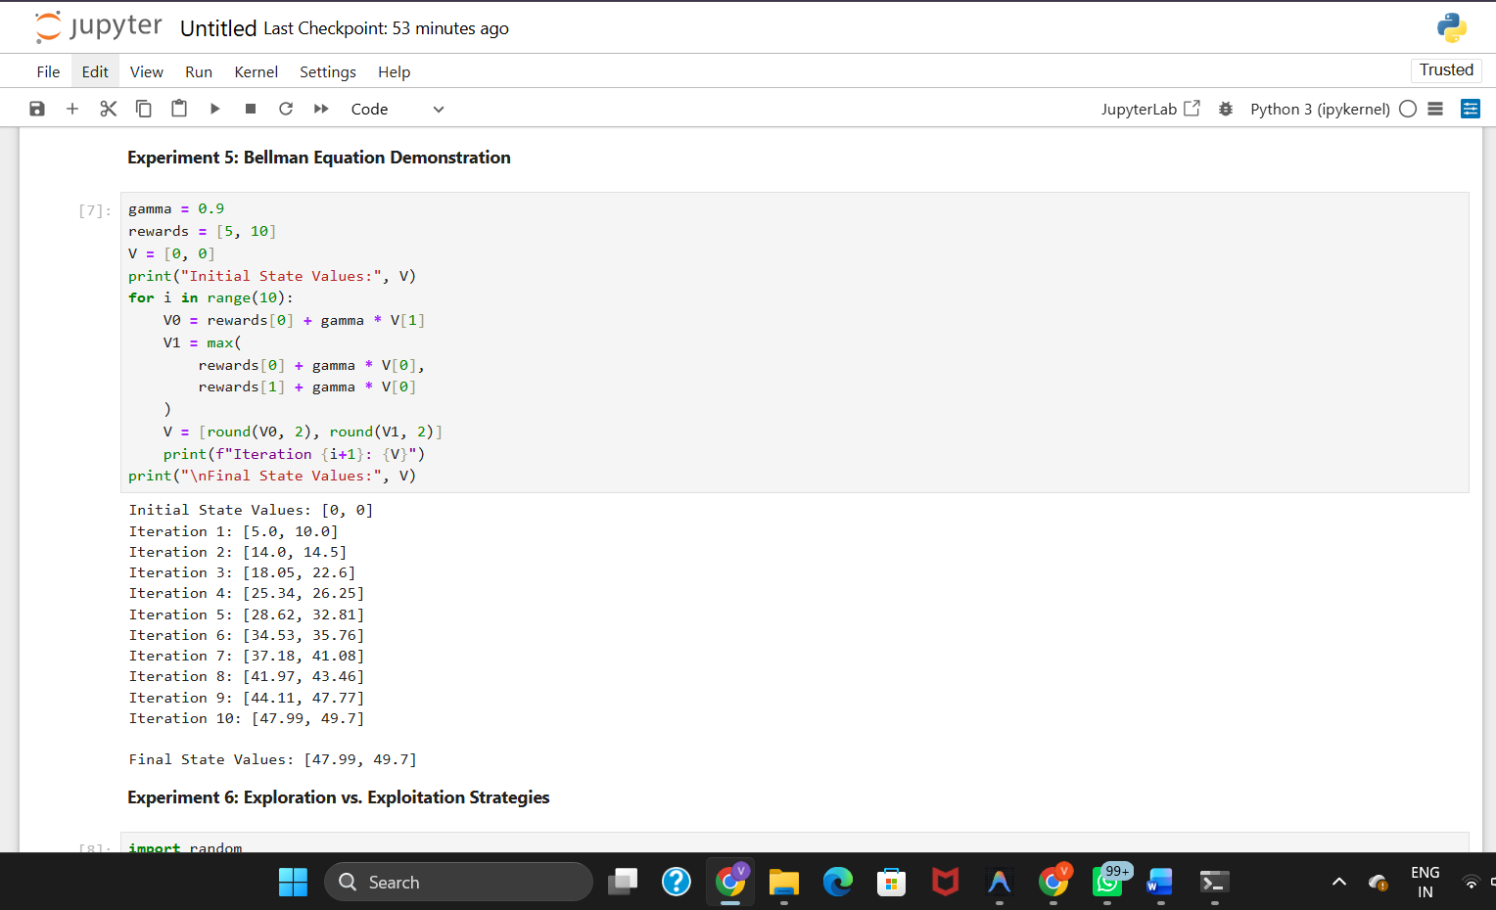

Experiment 6: Exploration vs. Exploitation Strategies
Aim:
To implement ε-Greedy, Greedy, and Random action-selection strategies and compare their performance in balancing exploration and exploitation during Reinforcement Learning.
Theory
- Greedy always selects the action with the highest estimated reward.
- Random selects actions randomly to explore the environment.
- ε-Greedy combines exploration and exploitation.
- Exploration discovers new actions, while exploitation uses the best-known action.
- ε-Greedy is widely used in Reinforcement Learning.
Explanation
- Initializes possible actions and rewards.
- Implements Greedy, Random, and ε-Greedy strategies.
- Selects actions using each strategy.
- Compares the selected actions and rewards.
- Evaluates the balance between exploration and exploitation.
Applications
- Recommendation systems
- Robot navigation
- Game AI
- Autonomous vehicles
Conclusion
The ε-Greedy strategy effectively balances exploration and exploitation, improving learning and decision-making compared to purely Greedy or Random approaches.

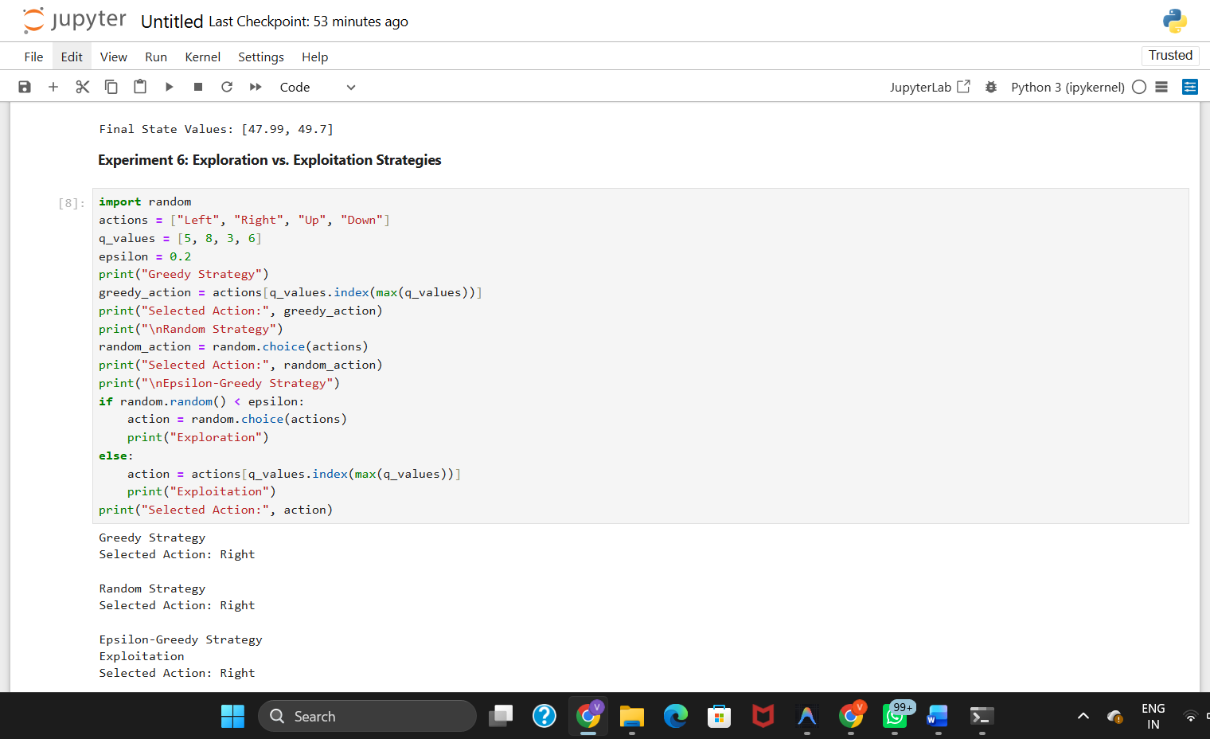

Experiment 7: Multi-Armed Bandit Problem
Aim:
To implement the Multi-Armed Bandit problem using ε-Greedy and Upper Confidence Bound (UCB) algorithms and evaluate cumulative rewards obtained by different action-selection methods.
Theory
- The Multi-Armed Bandit problem involves selecting the best action from multiple choices.
- ε-Greedy balances exploration and exploitation.
- UCB selects actions based on estimated rewards and uncertainty.
- The objective is to maximize cumulative rewards.
- These methods improve decision-making in uncertain environments.
Explanation
- Defines multiple actions with different rewards.
- Applies ε-Greedy and UCB algorithms.
- Selects actions over several iterations.
- Updates reward estimates after each action.
- Compares the cumulative rewards of both methods.
Applications
- Recommendation systems
- Online advertising
- Clinical trials
- Resource allocation
Conclusion
The Multi-Armed Bandit problem demonstrates how ε-Greedy and UCB strategies maximize cumulative rewards by balancing exploration and exploitation.

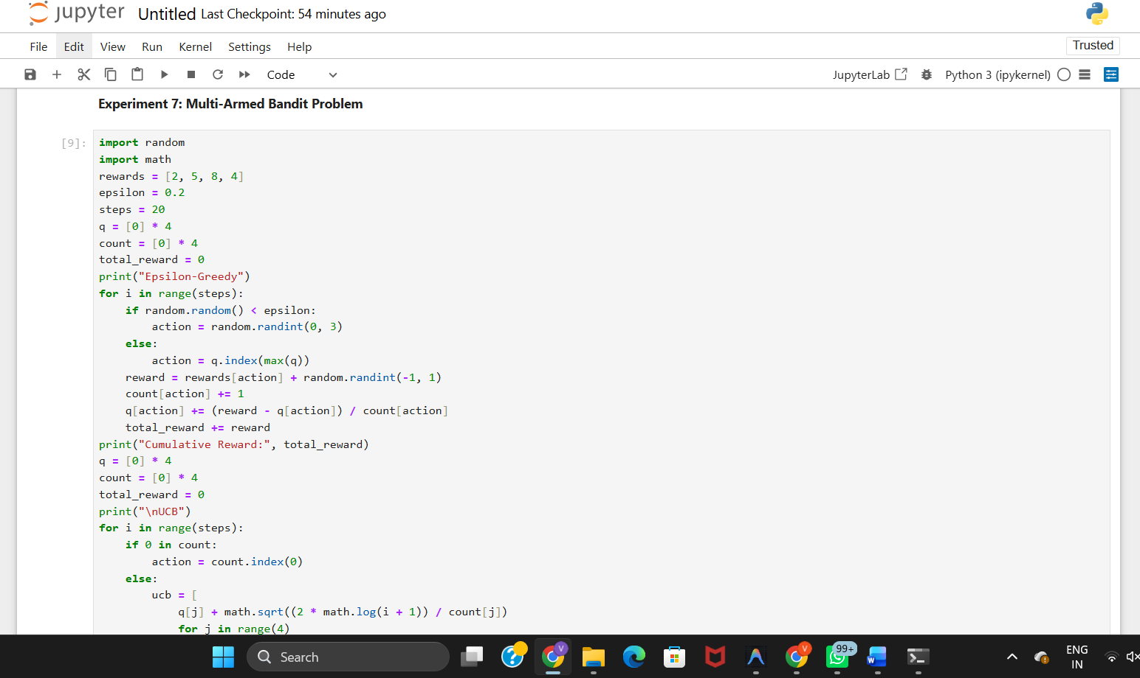
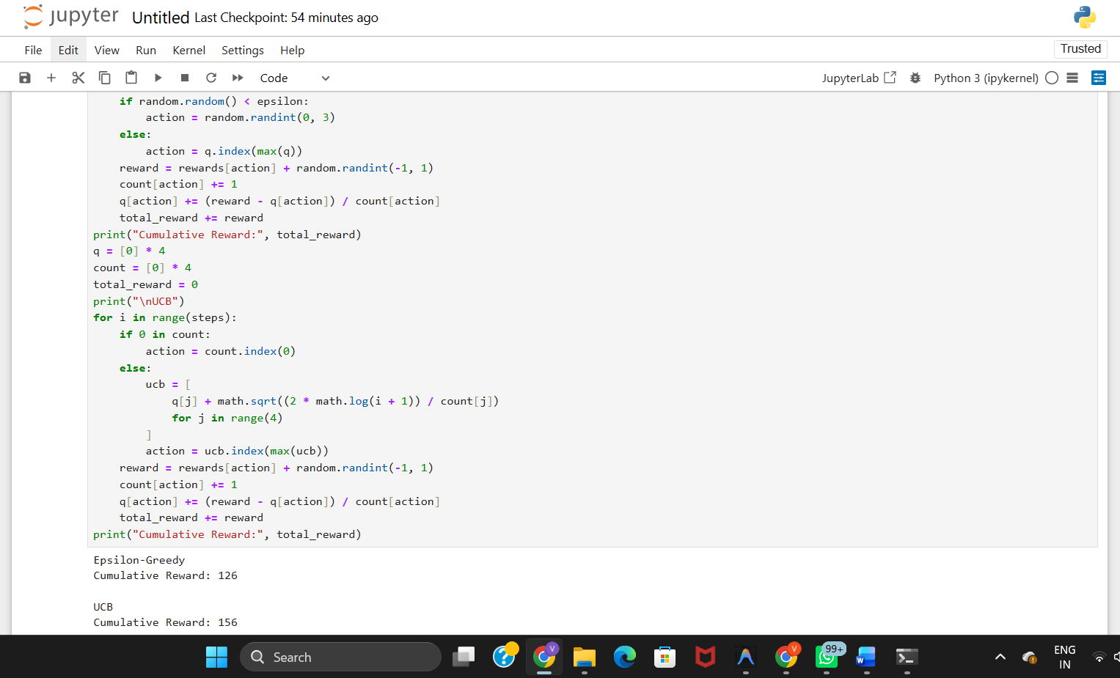

Experiment 8: Reward Visualization in Reinforcement Learning
Aim:
To simulate an RL agent in a simple environment and visualize cumulative rewards, episode rewards, and learning performance using Matplotlib graphs.
Theory
- An RL agent learns by interacting with an environment.
- Episode reward is the reward obtained in one episode.
- Cumulative reward is the total reward over multiple episodes.
- Matplotlib is used to visualize the learning performance.
- Graphs help analyze the agent's progress.
Explanation
- Simulates an RL agent for multiple episodes.
- Records the reward for each episode.
- Calculates cumulative rewards.
- Plots reward graphs using Matplotlib.
- Evaluates the agent's learning performance.
Applications
- Robot learning
- Game AI
- Autonomous vehicles
- Performance analysis
Conclusion
Reward visualization helps evaluate the learning progress of an RL agent by analyzing episode rewards and cumulative rewards through graphs.

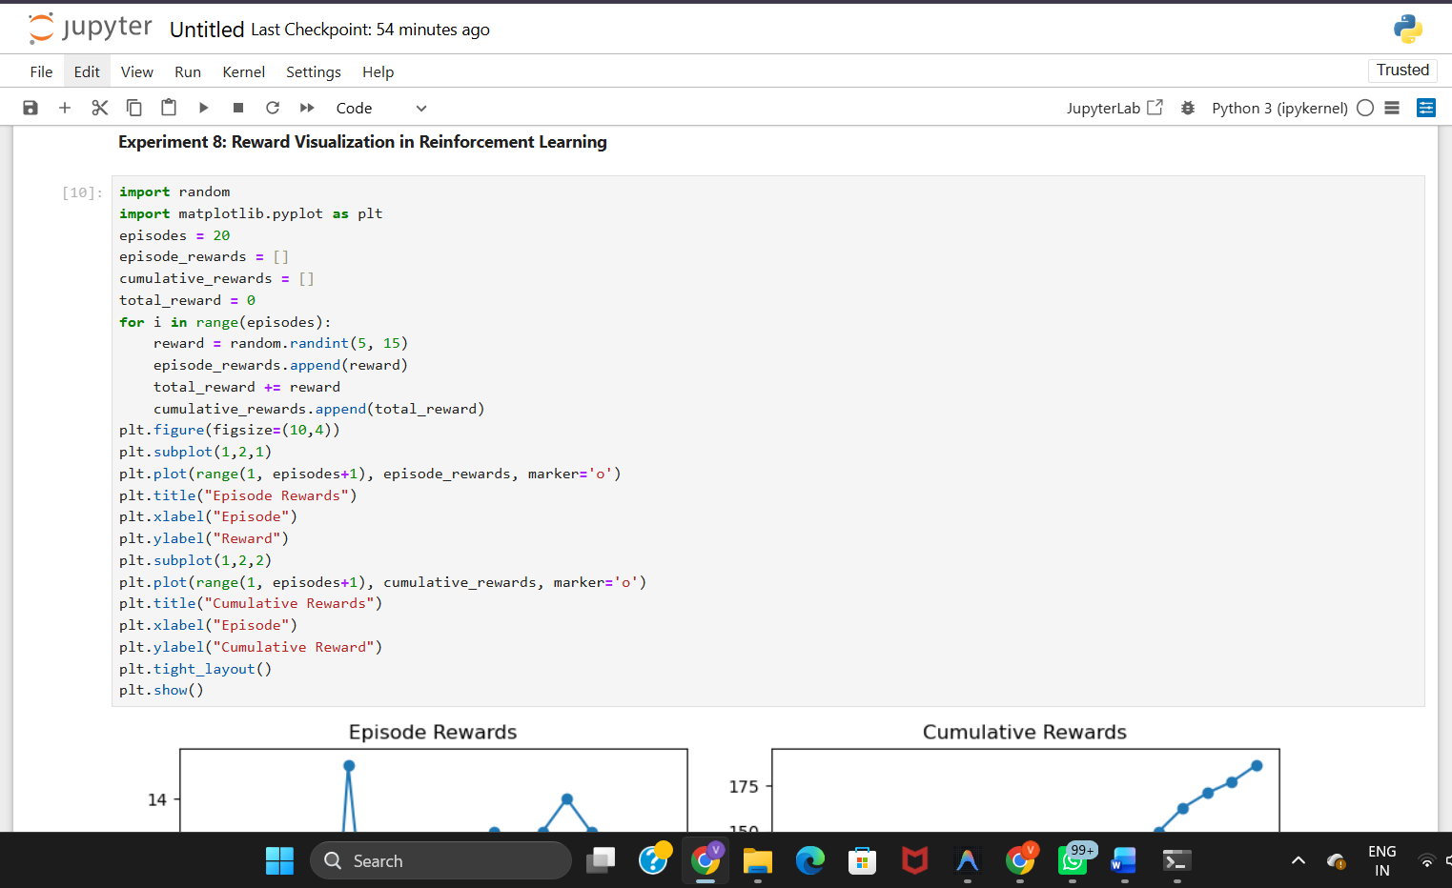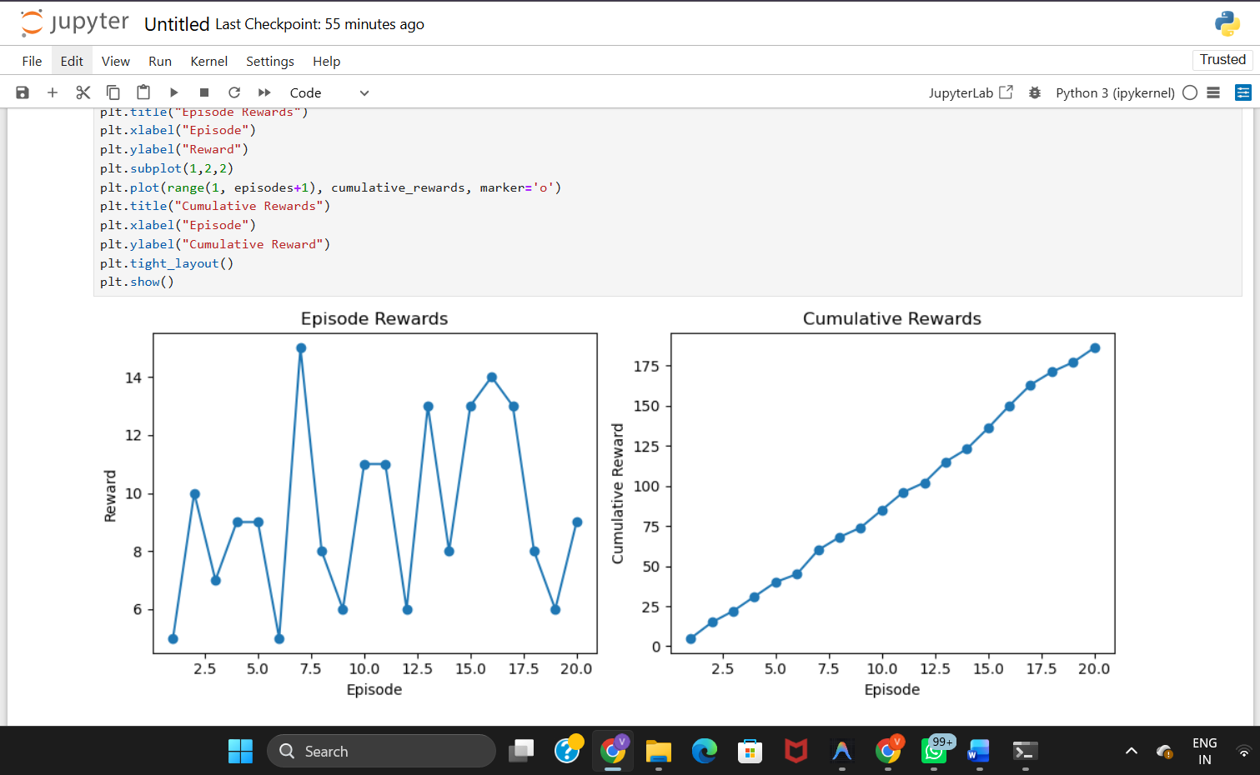

Experiment 9: TensorFlow and Keras-Based Neural Network for RL
Aim:
To build a simple feed-forward neural network using TensorFlow and Keras for approximating value functions in Reinforcement Learning environments.
Theory
- A feed-forward neural network consists of input, hidden, and output layers.
- TensorFlow and Keras are used to build and train neural networks.
- The network estimates state-value or action-value functions.
- It learns by adjusting weights during training.
- Neural networks enable Reinforcement Learning in complex environments.
Explanation
- Creates a feed-forward neural network.
- Defines input, hidden, and output layers.
- Compiles and trains the model.
- Predicts value estimates for input states.
- Evaluates the model's performance.
Applications
- Deep Q-Networks (DQN)
- Robot control
- Autonomous vehicles
- Game AI
Conclusion
A feed-forward neural network successfully approximates value functions, enabling Reinforcement Learning agents to make better decisions in complex environments.
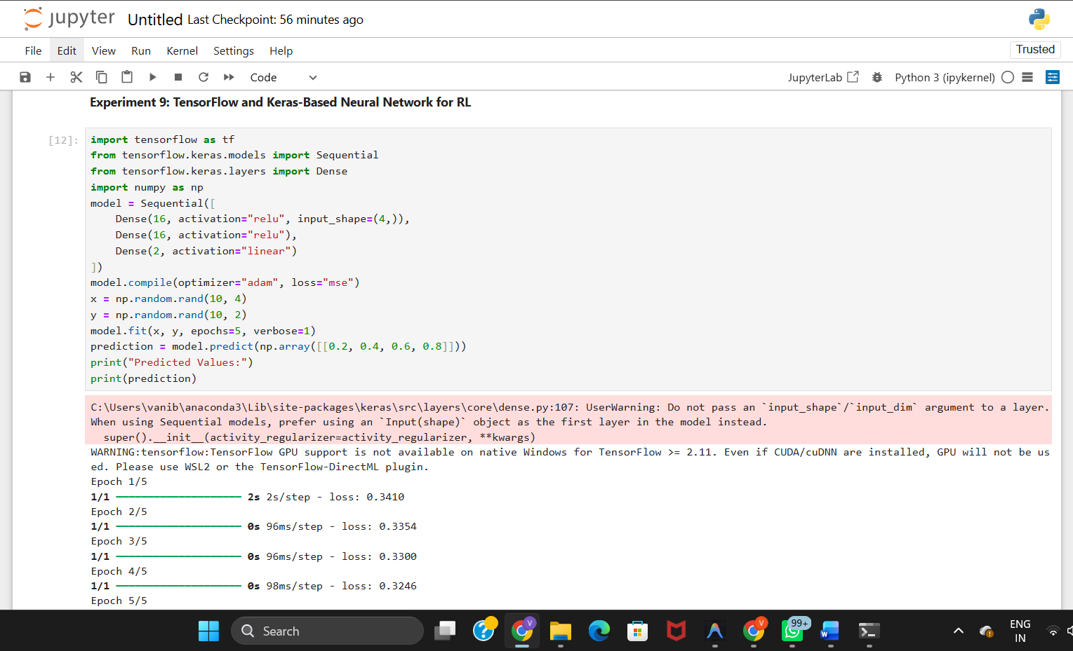
Experiment 10: Mini Reinforcement Learning Project Using CartPole
Aim:
To develop a basic Reinforcement Learning agent using TensorFlow and Keras to solve the CartPole environment and evaluate its learning performance through episode rewards and success rate.
Theory
- CartPole is a Reinforcement Learning environment where the agent balances a pole on a moving cart.
- The agent learns by interacting with the environment.
- TensorFlow and Keras are used to build the learning model.
- Episode reward measures the agent's performance.
- Success rate indicates how effectively the agent completes the task.
Explanation
- Creates the CartPole environment.
- Builds a neural network using TensorFlow and Keras.
- Trains the agent through multiple episodes.
- Records episode rewards and success rate.
- Evaluates the agent's learning performance.
Applications
- Robot balancing
- Autonomous vehicles
- Game AI
- Industrial automation
Conclusion
The Reinforcement Learning agent successfully interacts with the CartPole environment, and its performance is evaluated using episode rewards and success rate.

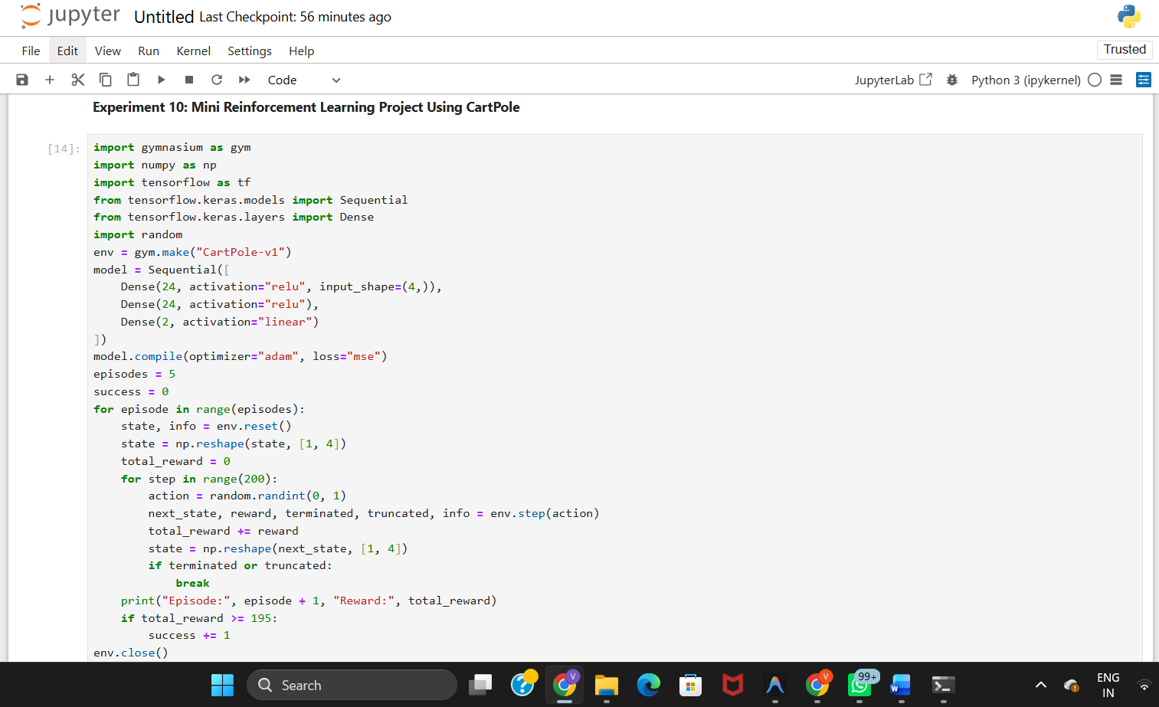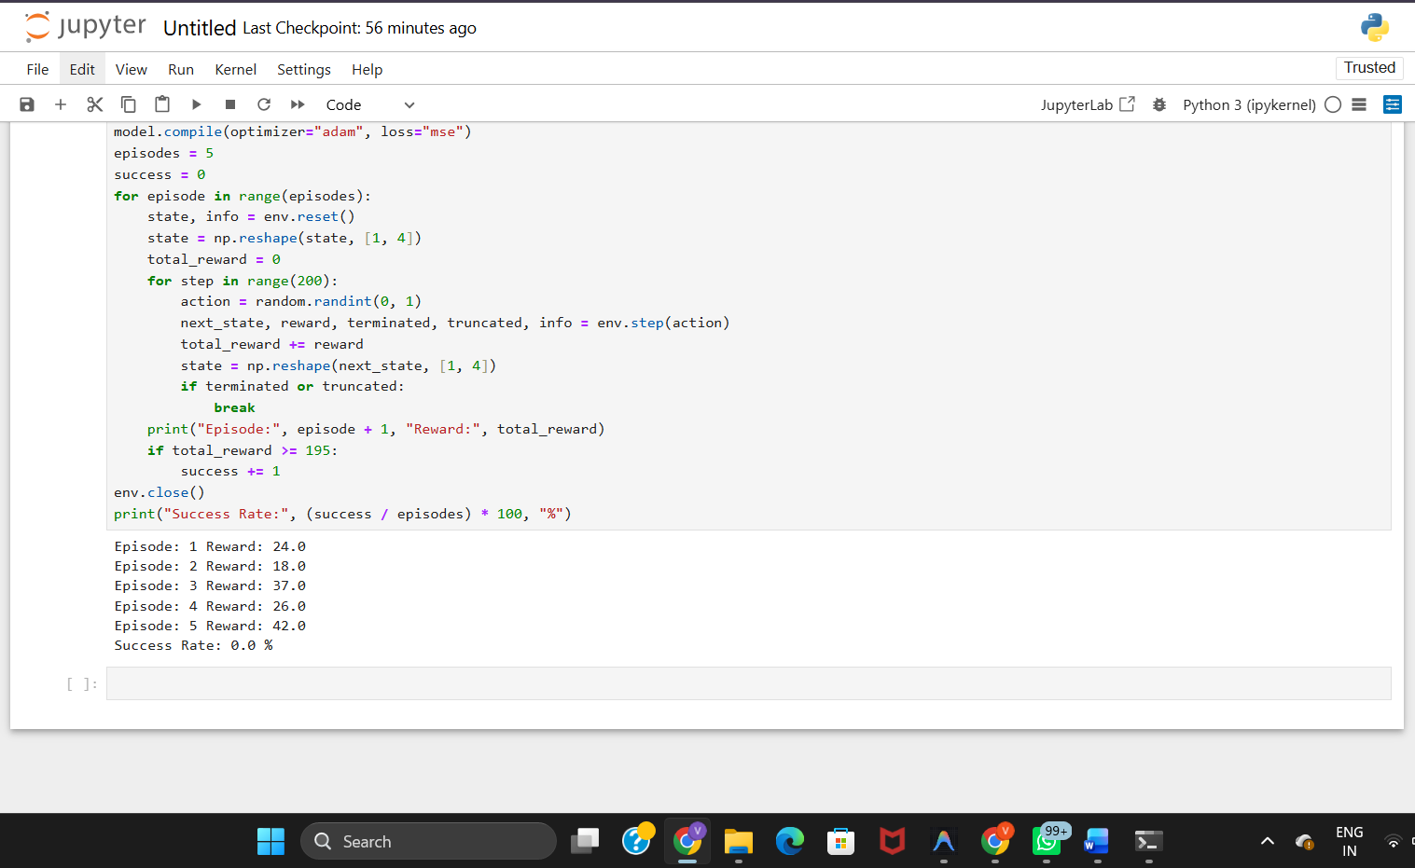

RUBRICS FOR CALCULATION

Criteria | Weightage | Level 4 – Exemplary | Level 3 – Proficient | Level 2 – Developing | Level 1 – Beginning
Understanding of Concepts | 25% | Demonstrates thorough, accurate understanding of concepts | Good understanding with minor gaps | Basic understanding with some misconceptions | Poor understanding; major misconceptions
Explanation | 25% | Detailed, well-explained answers with relevant examples | Clear explanation with adequate details | Limited explanation; lacks depth | Poor or unclear explanation
Application | 20% | Effectively applies concepts with strong analytical ability | Applies concepts with minor errors | Limited application with weak analysis | No application or incorrect analysis
Organization | 15% | Well-structured answers with logical flow and coherence | Organized with minor issues in flow | Basic structure, lacks clarity | Poor organization, incoherent answers
Accuracy | 10% | Completely accurate and covers all required points | Mostly accurate with minor omissions | Partially correct with missing points | Incorrect answers with major gaps
Clarity | 5% | Clear, neat, professional presentation | Understandable with minor issues | Limited clarity, readability issues | Poorly written, difficult to understand

